Hoping for the Best, Planning for the Worst

My Contribution
I provided that the main components of the risk management plan should include the purpose, roles and responsibilities, risk management strategy, risk management process, and risk documentation, and approvals.

Risk Management Plan
1.0 – Purpose
The purpose of this Risk Management Plan is to establish a formal process by which risks will be identified, mitigated or avoided, and managed for the PPI CSS Project. Effective risk management is a proactive and ongoing process in which we will seek to identify risks as early in the project as possible and implement controls to mitigate or avoid those risks. If possible, risks will be identified before they occur so that avoidance and mitigation efforts can be implemented to avoid any adverse impacts associated with those risks. The Risk Management Plan will define the processes by which risks and risk owners will be identified, risks will be evaluated, mitigation and avoidance measures will be evaluated, and risks will be tracked.

2.0 – Roles and Responsibilities
In order to ensure the successful completion of the PPI CSS Project, the roles and responsibilities of all key project personnel must be clearly defined with regards to project communication. In order to prevent overlap or gaps in project communication, the following roles and responsibilities have been identified:
Mr. Grant Strickland: The Project Sponsor is the approval authority for the PPI CSS Project. He is responsible for the approval of the Risk Management Plan as well as communicating all high-priority risks and mitigation and avoidance strategies to the Advisory Group.
Chief Technology Officer, Tanya Holcomb: The Chief Technology Officer is responsible for risk identification and providing timely and accurate status on all risks related to operational issues. She is also responsible for assisting the Project Manager in developing risk mitigation and avoidance strategies.
Project Manager, Mr. Fred Hatch: The Project Manager has overall responsibility for risk management on the PPI CSS Project. The Project Manager is responsible for developing and maintaining the Risk Management Plan. He is also responsible for ensuring the project has adequate resources for implementing the Risk Management Plan. The Project Manager will review risks and act as necessary and communicate all risk-related activities to the project team. He is responsible for the implementation of risk mitigation and avoidance strategies for all high-level risks.

3.0 – Risk Management Strategy
The strategy we will employ on the PPI CSS Project is a proactive approach to risk management. The goal of this strategy is to identify risks as early as possible in order to avoid or minimize any adverse impact the risks may have on the project. We will accomplish this by continuously evaluating critical project areas in order to identify risks, work as a cohesive team to determine the potential impact of each risk identified, develop and implement mitigation and avoidance strategies, and monitor the risks. This strategy will be conducted on the following tenets:
- Honest Assessment – It is imperative that all risks are identified and assessed in an honest manner. Risks cannot be controlled adequately if the full extent of the risk is not known.
- Full Participation – Everyone must participate in the identification of risks. Do not assume that others will identify all possible risks. Success depends on identifying all possible risks and in order to accomplish this everyone must participate actively.
- Balanced Risk Monitoring – It is key that risks are monitored often enough to adequately control them but not so often that progress is hindered.
- Simplicity – Complex and cumbersome risk tracking and measuring techniques are not necessary manage risk effectively. We will measure risks with low, medium, and high designations and spend more time managing risks rather than categorizing them.

4.0 – Risk Management Process
The PPI CSS Project will follow a phased risk management process: risk identification, risk assessment, risk control, and risk monitoring. These phases and activities do not occur one time, but rather they are ongoing throughout the project’s lifecycle. Once new risks are identified and assessed, they are controlled and monitored repeatedly until they are resolved and these actions are no longer required.
4.1 Risk Identification
Risk assessment is the process of evaluating critical project areas and processes in order to determine potential risks which may appear at any point during the project. A risk is any event or threat which may result in some type of adverse impact on the cost, schedule, or quality/performance of the project. The methods we will use to identify risks are:
- Analyze the WBS to determine areas where risk is most likely
- Interview subject matter experts (SME) to determine where, in each area, risks may be most likely
- Review project archives and lessons learned to determine where risks have occurred in similar projects in the past
- Review project risk database to determine most likely causes of risk
All project participants will play a key role and be relied upon heavily in identifying risks their given areas of expertise and knowledge.
4.2 Risk Assessment
Once the PPI CSS Project’s risks have been identified, they will be assessed in order to determine the priority in which they should be controlled and monitored. Additionally, the cause of the identified risks must be determined as well as their potential impact on the project. Each risk will be assessed by the project team in order to determine its probability of occurring and the impact it may have on the project. In order to quantify these risks, each will be assigned a score based on the probability and impact and will fall into the high risk(red), medium risk (yellow), or low risk (green) portion of the probability-impact matrix below.
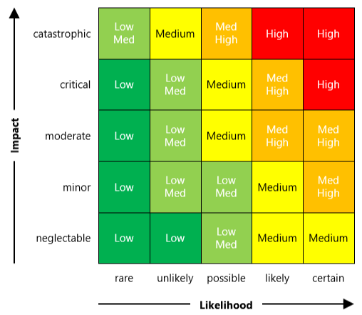
4.3 Risk Control
Risk control is the process in which the team will identify, evaluate, and implement measures to bring risks down to acceptable levels or avoid them altogether. Risks that require a mitigation or avoidance strategy will be assigned to a risk owner. The risk owner is responsible for providing risk status and all documentation associated with such in a manner consistent with the control strategy guideline below.
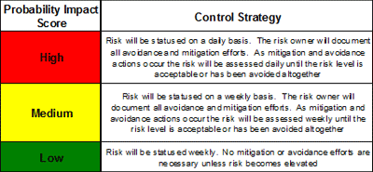
The risk owners for all high and medium risks must consider each of the following options for controlling risk:
- Alternative courses of action or workarounds
- Mitigation steps to reduce the probability or impact of the risk
- Changing project requirements to eliminate or reduce the probability or impact of the risk
- Risk acknowledgement which accepts the risk without taking any action
4.4 Risk Monitoring
Risk monitoring allows us to actively measure the performance of the risk control activities implemented to mitigate or avoid risks. Risk owners will develop risk control schedules for each of their assigned high and medium-level risks. Risk owners will provide the status of their risks and the progress of risk control measures in a frequency as noted in the control strategy chart above. This status will include anticipated risk control completion date, assigned resources for risk control activities, and changes in the probability or impact of the risk occurring.

5.0 – Risk Documentation
Documentation is an integral part of risk management as it not only allows us to effectively control and monitor risks associated with our project; but, it also provides a reference for future projects to research common causes of risks as well as mitigation and avoidance strategies. For the PPI CSS Project, a risk register will be created and maintained by the Project Risk Manager. The risk register will contain the identified risks, their probability-impact score, when the risk is due to occur, mitigation or avoidance control strategies, and the effectiveness of the risk control. The risk register will be maintained as an appendix to the PPI CSS Project Risk Management Plan.
6.0 – Approvals
The signatures of the people below indicate an understanding in the purpose and content of this document by those signing it. By signing this document you agree to this as the formal Risk Management Plan for the PPI CSS Project.

Approver Name | Title | Signature | Date
Grant Strickland | CEO
Tanya Holcomb | CTO
Fred Hatch | Project Manager

Possible Risks
Risk | Impact | Likelihood | Mitigation
Key staff could leave | 1 | 3 | Avoid
Funding risk | 4 | 2 | Accept
Equipment delay | 4 | 2 | Transfer
Data breaches | 4 | 1 | Reduce

Major Phases and Scenarios
The major phases of the PPI CSS Project are planning, executing, controlling and maintaining, and closing. Within the planning phase, it would be very problematic in the case of funding gets either reduced or retracted. It would be very difficult to proceed with all of the succeeding activities that are required in the remaining three phases. The executing phase can get very hectic when equipment either does not arrive on time or malfunctions. Depending on the type of equipment, the impact can vary greatly as several activities depend on these resources. The controlling and maintaining phase could run into a data breach. A data breach will significantly comprise both the reputation and business processes if deemed critical. If a key staff left the project during the closing phase, then its impact would be minimal as all major tasks of the project have already been completed.

References:
Risk Management Plan Template from FAST Project Plans. (2020). Retrieved July 11, 2020, from http://www.fastprojectplans.com/risk-management-plan-template.html
Schwalbe, K. (2016). Information Technology Project Management. [VitalSource Bookshelf]. Retrieved July 11, 2020 from https://bookshelf.vitalsource.com/#/books/9781305177789/

